**EMISSION AND PERFORMANCE STUDY IN HOMOGENEOUS CHARGE**

**COMPRESSION IGNITION (HCCI) ENGINE**

**S**.V. Ragul1, B. Santhosh Kumar2, C. Sridhar3, R. Santhosh4, S. Thamizh Selvan5

1,2,3,4,5 Department of Mechanical Engineering, Panimalar Engineering College, Chennai, India

[ragul7villa@gmail.com](mailto:ragul7villa@gmail.com)1, [santhosh3012003@gmail.com](mailto:santhosh3012003@gmail.com)2, [sridharyadv0@gmail.com](mailto:sridharyadv0@gmail.com)3, [santhoshmoorthy073@gmail.com](mailto:santhoshmoorthy073@gmail.com), [thamizh1899@gmail.com](mailto:thamizh1899@gmail.com)5

**Abstract**

Now a day we have a strict regulation in emission standards to operate an engine. If we worked for the better performance engine, we will not get the better emission standard engines. so far, we need a better performance and ultra low emission engines through HCCI mode of operation. Worldwide research work results, advantages and problems following from specific combustion process, typical for HCCI engines which is so different from well known and widely used spark and diesel engines. In this project we fabricated a engine frame and other accessories to converted a diesel engine to dual fuel engine at HCCI mode of operation. We fitted a carburetor in the diesel engine to supply the homogeneous charge in lean mixture ratio. The ignition timing is controlled by the diesel pilot injection system. By this we have got the result of ultra low emission engine, the emission from the engine is lesser than the BS-vi norms. We tested a both diesel and petrol in a gas analyzer and we got lesser emissions in both the test.

**Keywords**: Biodiesel, HCCI, Diesel, Performance, Emission, combustion

1. **Introduction**

Conventional diesel engines rely on compression ignition of an atomized liquid fuel jet injected into the high-temperature and high-pressure cylinder air charge toward the end of the compression stroke of a high compression-ratio unthrottled reciprocating piston engine. A brief review of the main specific features of these engines are shown in fig (2.1) and how they differ from the common spark ignition type follows:

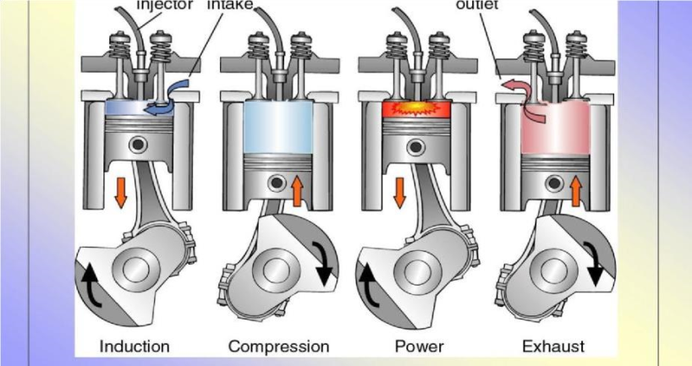

Fig.1 **working of diesel engine**

Diesel engines need to have sufficiently high compression ratios to ensure reliable, prompt, and well controlled autoignition of the injected fuel. They involve non homogeneous fuel–air mixtures leading mainly to heterogeneous diffusion type combustion. The rapid energy releases produced require robust engine construction to withstand the resulting high mechanical and thermal loading rates. The engine requires suitable liquid fuels that, in comparison to those of the spark ignition, are more prone to auto-ignition and have high cetane numbers, but at the same time very low octane numbers. Excess air operation is employed throughout with intense turbulence and swirling fluid action provided so as to aid in the rapid atomization, vaporization, and subsequent mixing of the fuel and air. The engine normally operates un throttled at lower speeds than the spark ignition types and is relatively harder to start unaided under cold weather and intake air conditions. But it tends to have superior work production efficiency and torque characteristics. The engine is well suited for high levels of turbocharging and can be made of extremely large size and power capacity.

The exhaust emissions in diesel engines tend to show normally low levels of carbon monoxide and unburned hydrocarbons, but relatively high levels of NOx and particulates. At present, to render their exhaust gas emissions environmentally acceptable, most engine types require special treatment. The many improvements made in recent years in diesel engine design, manufacture, and performance, such as in their superior fuel injection systems, are very impressive. They led to significant improvements in key performance features, such as power production, brake torque characteristics, driving dynamics, fuel utilization, increased reliability, and reduced exhaust emissions. The engine has been recognized almost from its inception as having the capacity to operate on a multitude of fuels, varying from gaseous to even solid-liquid slurries. The engine was originally conceived as capable of using cheap low grade liquid fuels, but with the more recent stricter requirements to achieve sufficiently low exhaust emissions combined with high efficiency, ultra-low sulfur-distilled liquid fuels are required.

### 2.2 HCCI ENGINE

#### *2.2.1 History*

Amongst the numerous research papers published over the last decade, the homogeneous charge compression ignition (HCCI) or controlled auto-ignition (CAI) combustion has often been considered a new combustion process in reciprocating internal combustion engines. However, it has been around perhaps as long as the spark ignition (SI) combustion in gasoline engine and compression ignition (CI) combustion in diesel engines. In the case of diesel engines, the hot-bulb 2-stroke or 4-stroke oil engines or diesel engines were patented and developed over 100 years ago , wherein kerosene, or raw oil was injected on to the surface of a heated chamber (hot-bulb), which was separated from the main cylinder volume, very early in the compression stroke, giving plenty of time for fuel to vaporize and mix with air. During the start-up, the hot bulb was heated on the outside by a torch or a burner. Once the engine had started, the hot-bulb was kept hot by the burned gases within. The bulb was so hot that the injected fuel vaporized immediately when it got in contact with the surface. Later design placed injection through the connecting passage between the hot-bulb and the main chamber so that a more homogeneous mixture could be formed, resulting in auto-ignited homogeneous charge combustion.

***2.2.2 Principle of HCCI Engines***

The premixed fuel and air mixture is then compressed. Towards the end of the compression stroke, combustion is initiated by auto-ignition in a similar way to the conventional CI engine. The temperature of the charge at the beginning of the compression stroke has to be increased to reach auto-ignition conditions at the end of the compression stroke. This can be done by heating the intake air or by keeping part of the hot combustion products in the cylinder. Both strategies result in a higher gas temperature throughout the compression process, which in turn speeds up the chemical reactions that lead to the start of combustion of homogeneously mixed fuel and air mixtures the ignition and combustion of HCCI engine is shown in fig (2.2).

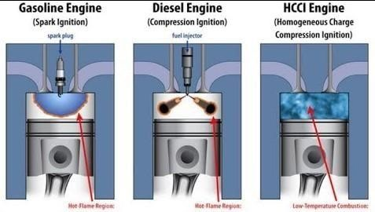

#### Fig 2.2 principle of operation

Although the start of main heat release usually occurs when the temperature reaches a value of 1050–1100K for gasoline or less than 800K for diesel, many hydrocarbon components in gasoline and diesel undergo low temperature oxidation reactions accompanied by a heat release that can account for up to 10% of the total energy released. The contribution of the low temperature energy release to obtaining auto-ignition and heat release rate from the HCCI/ CAI combustion depends not only on the unique chemical kinetics of the fuel used and the dilution strategy, but also on the thermal conditions or the temperature-pressure history that the mixture goes through during compression. In an idealized HCCI/CAI engine, the auto-ignition and combustion will take place simultaneously throughout the combustion chamber, resulting in a rapid rate of heat release. In order to prevent the runaway heat release rate associated with the simultaneous burning of mixtures, HCCI/CAI engines have to run on lean or/and diluted fuel and air mixtures with burned gases. The heat release characteristics of the HCCI/CAI combustion can be compared with those of SI and CI combustion using Fig. 1.1. In the case of SI combustion, a thin reaction zone or flame front separates the cylinder charge into burned and unburned regions and the heat release is confined to the reaction zone. The cumulative heat released in a SI engine is therefore the sum of the heat released by a certain mass, *dim*, in the reaction zone and it can be expressed as

**Q =** where *q* is the heating value per unit mass of fuel and air mixture, *N* is the number of reaction zones.

In an idealized HCCI/CAI combustion process, combustion reactions take place simultaneously in the cylinder and all the mixture participates in the heat release process at any instant of the combustion process. The cumulative heat release in such an engine is therefore the sum of the heat released from each combustion reaction, *dqi*, of the complete mixture in the cylinder, m.

1. **Experimental Setup and Procedure**

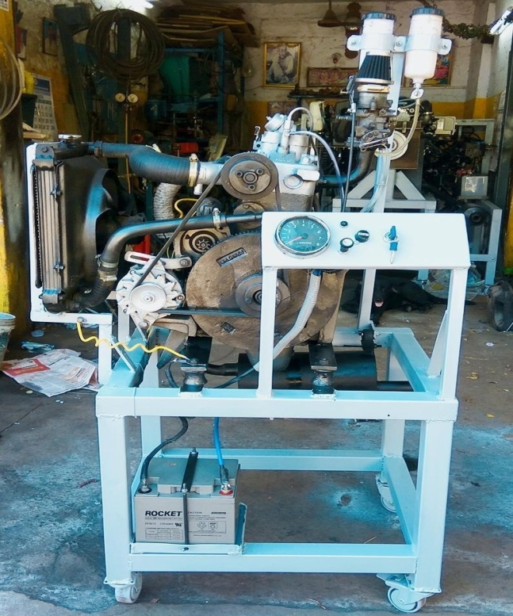

**Fig6.1 Photograph(front view)**

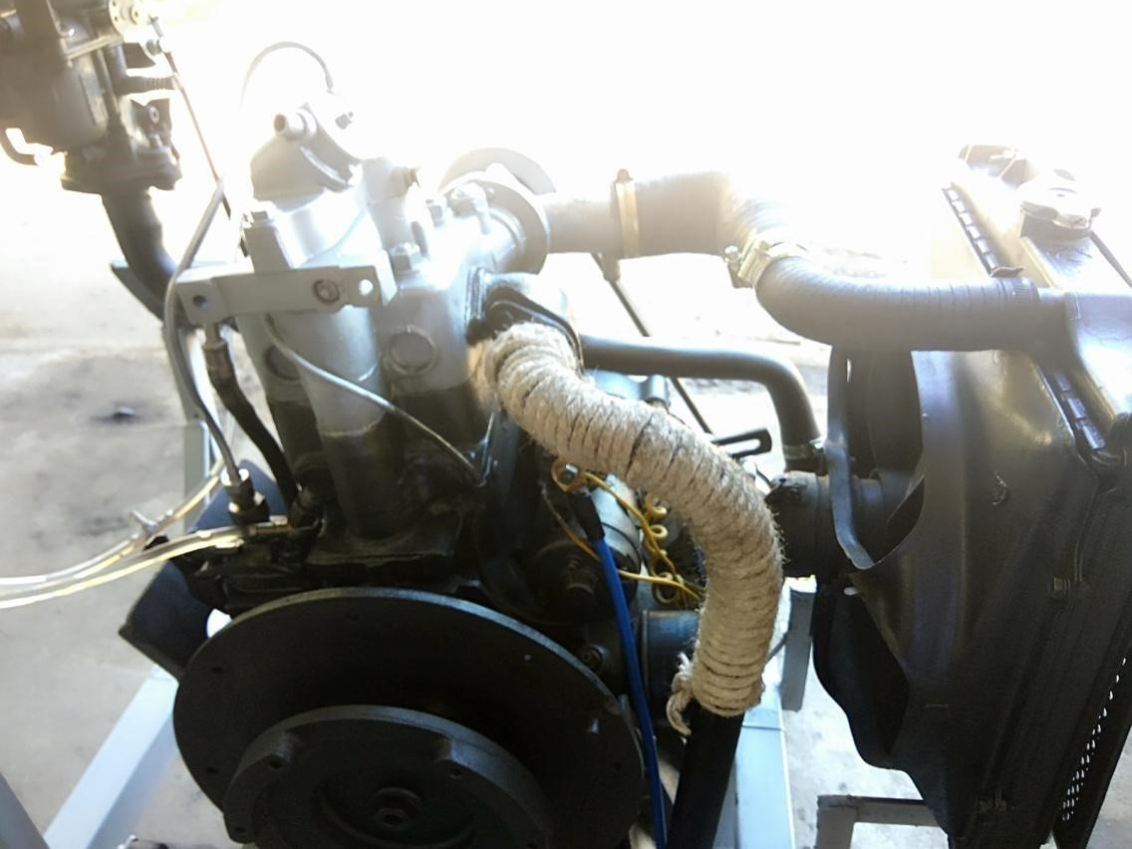

##### Fig6.2 Photograph (back view)

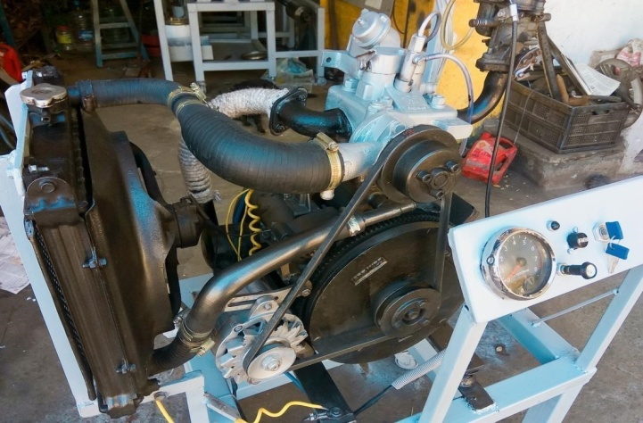

**Fig6.3 Photograph (isometric view)**

**Controls**

With out controls every machine is dangerous to operate and service. In this project we have anself starter switch to start the engine automatically and check lights are fitted to know the output of alternator. we also have an stop lever cable to shutdown the engine whenever we want. In main we have an ignition key to switch on & off the main line of engine for security purpose. Radiator fan will operate automatically, when the ignition switch is ON to reduce the increase of heat in engine block. It will reduce or prevent the engine from knocking.controls are shown in the fig (4.5) and also we have an

RPM meter to show the perfect RPM of the engine, it plays major role to control the engine.

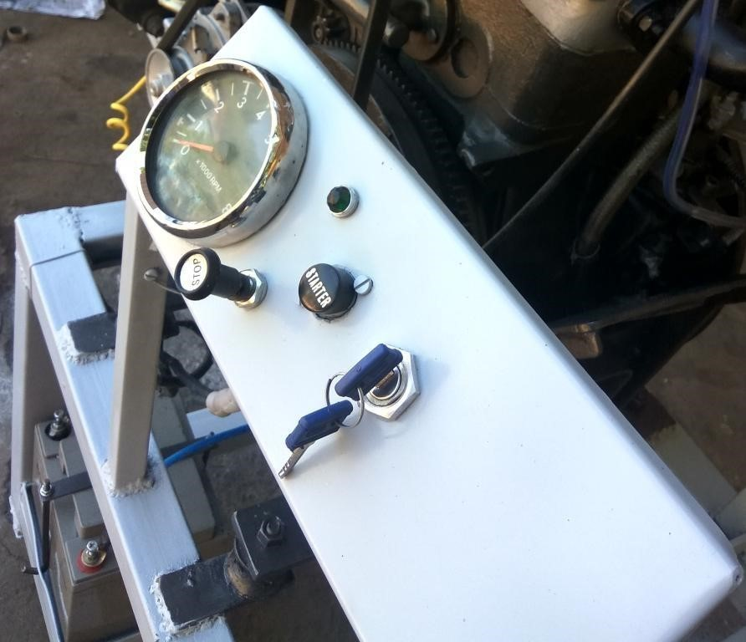

**Fig 4.5 controls**

#### Assembly of Carburettor

We fitted a single jet carburetor to abtain a homogeneous charge. And also we sealed the main jet of the carburetor as shown in the fig(4.3). High speed jet are disconnected from the lever and spring, so far we cannot get the excess fuel from the jet when we adjust the throttle to set the lean air-fuel mixture ratio .

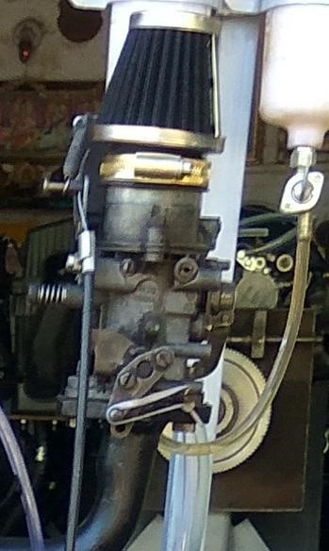

#### Fig 4.3 carburetor

And also the engine filter is fitted in the carburetor to clean the air.

Almost we set the air-fuel mixture nearer to lean mixture ratio , so far we can obtain the less emissions and exhaust gas temperature. We connected the stop lever cable and control cable to the carburetor.

##### **Modifications in Diesel Injector**

In diesel engine we have an injector to inject the diesel directly into the cylinder for a combustion as shown in the fig (4.4). so in this engine setting or converting of normal injection to pilot injection is much more complicated to do. If we have to change the injection , the only way is to change the diesel injection pump cam. But we converted the main injection or normal inection to pilot injection by the increase of pressure in injector. We setted the engine at very low idle, so the diesel injection is also very low but we need much more lesser injection than the idle injection, we added 4 shims to increase the injection pressure in that idle if pressure increases the delivery of the injector is decreases.

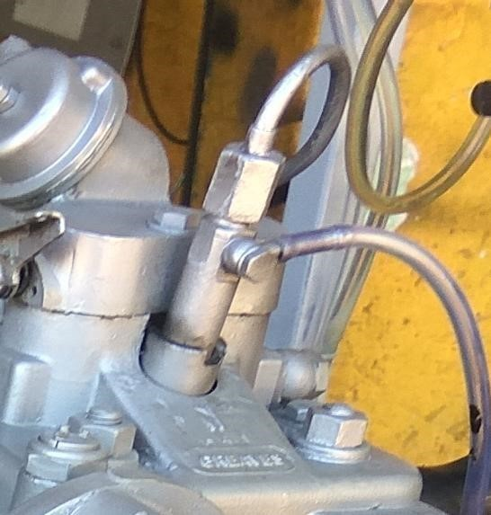

**Fig 4.4 mechanical diesel injector**

We can get almost the pilot injection and also we converted the diesel engine to duel fuel engine.

1. **Results and Discussion**

### EMISSION COMPARISONS

### Emission standards

Emission standards are the legal requirements governing air pollutants released into the atmosphere. Emission standards set quantitative limits on the permissible amount of specific air pollutants that may be released from specific sources over specific timeframes. They are generally designed to achieve air quality standards and to protect human life is shown in fig(5.1) .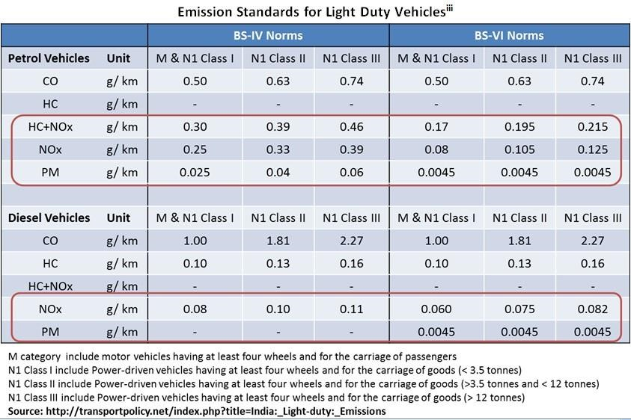

#### Fig5.1 Emission standards

Many emissions standards focus on regulating pollutants released by automobiles (motor cars) and other powered vehicles. Others regulate emissions from industry, power plants, small equipment such as lawn mowers and diesel generators, and other sources of air pollution.

1. **Conclusion**

In this project we made and tested a HCCI mode of charge will vary the emission and it also leads to ultra low emissions and reduced exhaust gas temperature . And also we learned about the auto ignition of fuel and controlled auto ignition of the engine. And also we introduced a new method of pilot injection systems to the engine market. We have tested with both diesel and petrol engine gas analyzer. It will results lesser than BS-VI norms and the engine is under control by diesel pilot injection system. By this engine we got aultra low emissions vehicle (ULV) and it is nearer to zero emission vehicle (ZEV).

**References**

[1] Shigeru Onishi, Souk Hong Jo, KatsujiShoda, Pan Do Jo, Satoshi Kato: ”Active ThermoAtmosphere Combustion (ATAC) – A New

Combustion Process for Internal Combustion Engines”, SAE 790501

[2] M. Noguchi, Y. Tanaka, T. Tanaka, Y. Takeuchi: ”Takeuchi Study on Gasoline Engine Combustion by Observation of Intermediate Reactive

Products during Combustion”, SAE 790840

[3] P. Najt, D.E. Foster: ”Compression Ignited Homogeneous Charge Combustion”, SAE 830264

[4] Thring, R.H: ”Homogeneous Charge Compression Ignition (HCCI) Engines”, SAE 892068

[5] T.W. Ryan, T.J. Callahan: ”Homogeneous Charge compression

Ignition of Diesel Fuel”, SAE 961160

[6] M. Stockinger, H. Schäpertöns, P. Kuhlmann: „Versuche an einemgemischansungendenVerbrennungsmotormitSelbstzündung“, MTZ,

MotortechnischesZeitschrift 53 (1992) pp 80-85.

[7] N. Lida: „Combustion Analysis of Methanol-Fueled Active ThermoAtmosphere combustion (ATAC) Engine Using a Spectroscopic

Observation”, SAE 940684

[8] T. Aoyama, Y. Hattori, J. Mizuta, Y. Sato: ”An Experimental Study on PremixedCharge Compression Ignition Gasoline Engine”, SAE 960081

[9] P. Duret: ”Automotive Calibration of the IAPAC Fluid Dynamically

Controlled TwoStroke Combustion Process”, SAE 960363

[10] R. Gentill: ”Experimental Study on ATAC (Active ThermoAtmosphere Combustion) in

Two-Stroke Gasoline Diesel Engine”, SAE 970363